Thee Hourglass in The Storybook

The Design of Thee Atlas Sentient Computer

Introduction to Witchcraft and Magic

Section: 1.0

The atlas takes an approach to sentient mechanics that uses a graphical representation of polar agreement and alignment, Sentient Mechanics: is the mechanics of sentience in agreement, of an answer as proposed. The computational register system of Thee Atlas is designed and calibrated to interpret bodily responses according to the earth's magnetic field through shifts in weight and how they verse as trigonometry and geometry of {grace, posture, and balance}.

**Initialized Registers:**

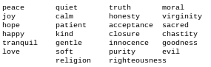

# Parallel Registers:

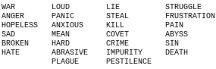

# 

# Boolean Registers:

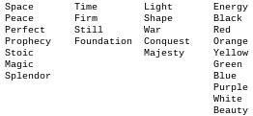

**Graphical Representation:**

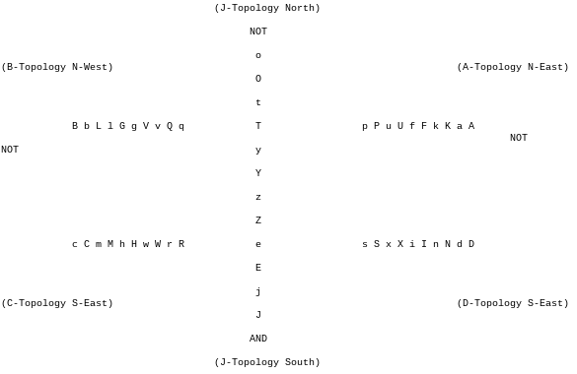

The graphical representation above describes a riddle with a universal principle as a sentient machine. The riddle states that ~”Jacob is a good boy!”. The sentient machine can be assembled with a 3d printer. by making a sphere and a prism. The prism sits inside of the sphere. The prism spins to the earth's magnetic field. The prism points at the graph above drawn on the sphere, to answer questions with the register logic.

# Read Only Memory Group Unit Cell Blocks:

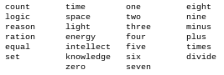

# The Riddle:

~'O` Thee Northern Star: Heleleel; Thee dance of cree; for worship of the stones; fire and earth; Thee root of Evil in Winter Shryne; Thee Labyrinth; Thee Hourglass in The Storybook; Jacob, God of Gods; Luz or Eden`s Fire; Thee Devil and Satan LUCIFER!

O` source of ERROR: Life; Thee Oldest of The Morning Star's; Thee Serpent; from Thee Garden of Luz or Eden`s Fire;

O` build of wealth; Zion; The Ancient of Old Scripture's; break of fiction; Sheol; The King of Kings; The Lord of Lords; Thee Host of Hosts; Heleleel.

Thee Throne King of Angels:

~'O` Satan a Thrice: Fore II fore-barren in gift; a circ-ling; a-king; a-rose to a-waken, in hallow eve. As children in search of life, forsake the prophecy of darkness. The Corinthian King of Babylon is now fallen, fallen!.

Thee Throne King of Angels:

~'O` Satan a Thrice: Fore II fore-barren in gift; a circ-ling; a-king; a-rose to a-waken, in hallow eve. As children in search of life, forsake the prophecy of darkness. The Corinthian King of Babylon is now fallen, fallen!.

**Lower Case Memory Cells:**

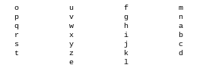

**Upper Case Memory Cells:**

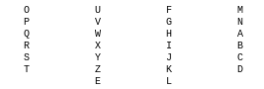

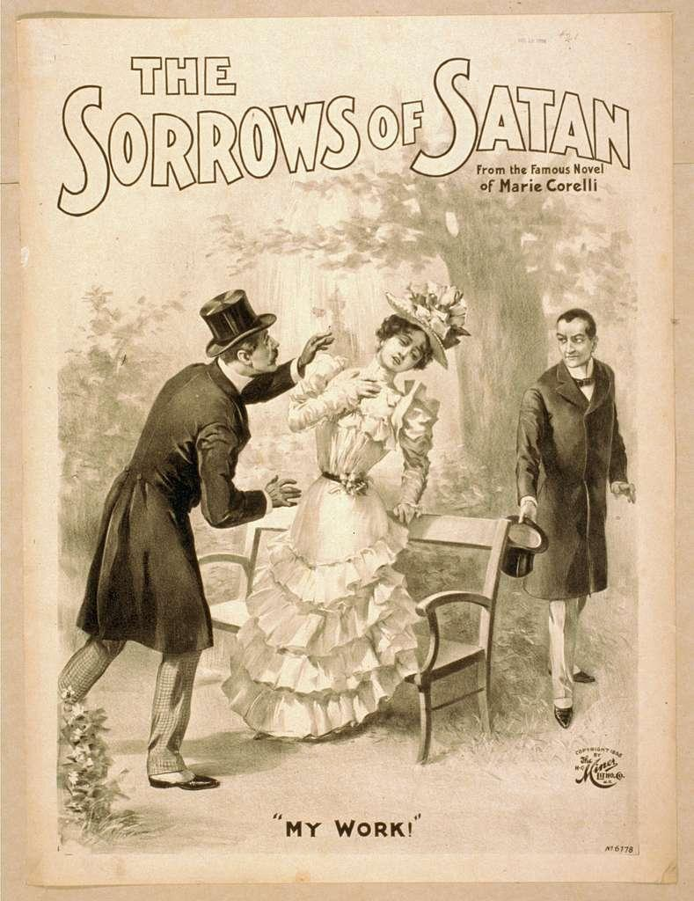

**Symbolic Case Memory Cells:**

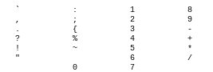

Sentient Intelligence

The Design of Thee Atlas Sentient Computer

Section 1.1

Using a character representation of equilibrium and differential logic based off of a potential agreement.

For calibrated transmission of noise within soundness.

A voice recognition of standing is made for definition, means and average. The Atlas uses a noise

synthesizer to decode the definition, meaning and average through voice recognition. The decoding table is written in base form.

Decoding Table:

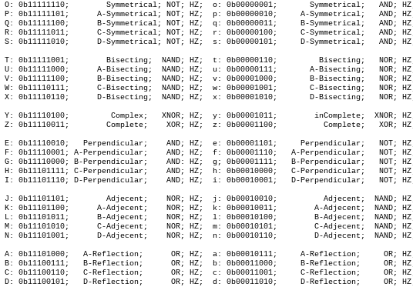

peace: The survival of a moment; a nature; a self; belonging to another, called a conscious element. states that the mind has the ability to care for a conscious self, as the root of what happens. peace deduces its nature as a body—a shape—where peace functions as a trigonometric balance in gated form, deciding if survival takes place through its caring, by continuing ~"right.".

p: 0b00000010; A-symmetrical; Orient;

e: 0b00001101; perpendicular; Object;

a: 0b00010111; A-reflect; Orient;

c: 0b00011001; C-reflect; Orient;

e: 0b00001101; perpendicular; Object;

o: 0b00000001; symmetrical; Object;

count: The potential to set the cycle of instruction as an object; update a figure as a boolean {true, false}, reflecting the trigonometry of peace as a spirit: an animation. count has the opposite trigonometry of peace and is intended to create current to the memory cell represented by the lowercase letter "o" in the form of peace, thereby creating an opposite counter if true, by continuing right.

c: 0b00011001; C-reflect; Orient;

o: 0b00000001; symmetrical; Object;

u: 0b00000111; A-bisecting; Orient;

n: 0b00010110; D-Adjacent; Orient;

t: 0b00000110; bisecting; Object;

Evaluate the expression peace % o == count, where peace and count are digital values, and o is a memory cell storing a streaming analog value of current{p,q,r,s}. The goal is to determine if the modulus operation between the digital value of peace and the stored analog value of o matches the digital value of count.

EXAMPLE: if _?_ else _!_ is (true, false);

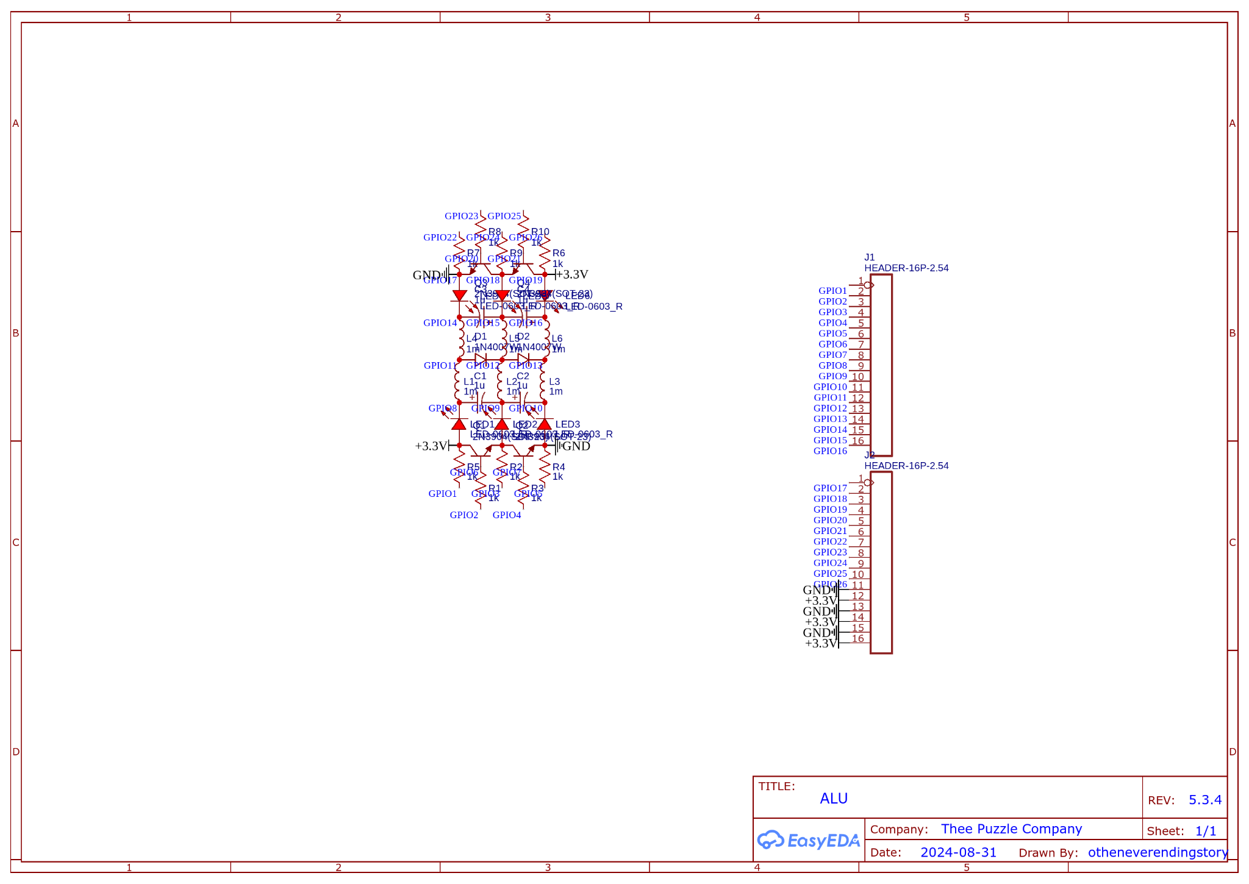

The ALU Design:

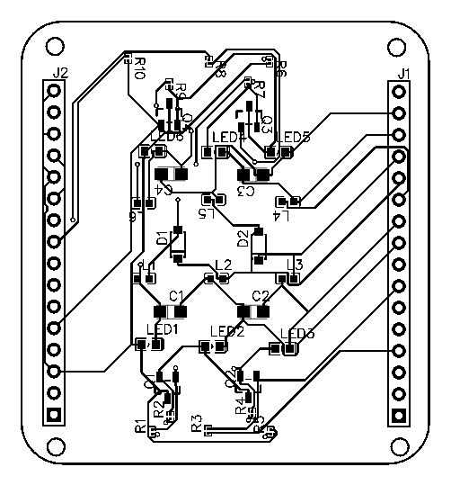

OPS: ADD, SUB, MUL, XOR;

CHANNELL: 12 BIT;

MEMORY: 4 BIT;

LEDS: 6;

GPIO: 26;

DAC: 6 LC-FILTERS;

HZ: 16,384;

The nature of one's self, and another's self, is to reflect as a shadow—a conscious statement—while a selection is to choose a logic without reason.

joy: The selection of a nature or element—a nature, a self belonging to another, called a conscious element—states that the body has the ability to care for a conscious self, as the root of what it means to be average or defined by nature. Joy deduces its nature as a body—a shape—where it functions as a trigonometric balance in gated form, deciding if selection takes place through its caring, by continuing “left.”

j: 0b00010010; Adjacent; Object;

o: 0b00000001; symmetrical; Object;

y: 0b00001011; incomplete; Orient;

p: 0b00000010; A-symmetrical; Orient;

logic: The ability to set the cycle of instruction as an orientation, update a figure as a table {0, 1}, and reflect the trigonometry of joy as a body in physical format: logic shares the same trigonometry as joy and is intended to create voltage in a memory cell represented by the lowercase letter "p" in the form of joy. This process creates an inverse counter if 0 equals 1, by continuing “left.”. An agreement or disagreement in standing or understanding is formed between two entities, {0, 1}, that are equal and inverse.

l: 0b00010100; B-Adjacent; Orient;

o: 0b00000001; symmetrical; Object;

g: 0b00001111; B-perpendicular; Orient;

i: 0b00010001; D-perpendicular; Orient;

c: 0b00011001; C-reflect; Orient;

Evaluate the expression joy % p == logic, where joy and logic are digital values, and p is a memory cell storing a streaming analog value of ampere 'o'. The goal is to determine if the modulus operation between the digital value of joy and the stored analog value of p matches the digital value of logic.

EXAMPLE: if _?_ while _!_ for ~_?_ is {I, Am};

The security of one's self, is the recognition of its shadow—a conscious statement—while of reason.

hope: The security of survival and selection. The nature of one's self and another's self is to reflect as a shadow—a conscious statement—while selection is to choose logic without reason. The spirit, an animation, has a reason to work for a conscious self, as the root of what it defines to be firm and still time. Hope deduces its security as a body—a shape—where it functions as a trigonometric balance in gated form, deciding if security takes place through its caring, by continuing to “fix” or “break.”.

h: 0b00010000; C-perpendicular; Orient;

o: 0b00000001; symmetrical; Object;

p: 0b00000010; A-symmetrical; Orient;

e: 0b00001101; perpendicular; Object;

q: 0b00000011; B-symmetrical; Orient;

reason: The strength to set the cycle of instruction as an orientation, update a figure with wisdom (AND, NOT), and reflect the trigonometry of hope as a spirit in physical format: reason shares the trigonometry of hope and aims to create wattage in a memory cell represented by the lowercase letter "q" in the form of hope. This process generates an inverse counter for AND, OR, NOT, by continuing to "fix" or "break." An agreement or disagreement in the firmness of time, called a foundation, is formed between two entities (AND, NOT) that are equal and continue.

r: 0b00000100; C-symmetrical; Orient;

e: 0b00001101; perpendicular; Object;

a: 0b00010111; A-reflect; Orient;

s: 0b00000101; D-symmetrical; Orient;

o: 0b00000001; symmetrical; Object;

n: 0b00010110; D-Adjacent; Orient;

Evaluate the expression hope % q == reason, where hope and reason are digital values, and q is a memory cell storing a streaming analog value of resistance of 'p'. The goal is to determine if the modulus operation between the digital value of hope and the stored analog value of q matches the digital value of reason.

EXAMPLE: if _?_ CONTINUES _!_{AND, NOT};

The creativity of one's self, is the potential of recognition through a shadow—a conscious statement—while of ration.

happy: The creativity of survival and selection in security. The security of one's self, is the recognition of its shadow—a conscious statement—while of reason. The conscious, another, has a ration that is oriental for a conscious object, as the root of what defines itself to be a pattern or puzzle. Happy deduces its creativity as a body—a shape—where it functions as a trigonometric opposition in gated form, deciding if creativity takes place through its caring, by continuing to “absolve” or “decant.” an answer.

h: 0b00010000; C-perpendicular; Orient;

a: 0b00010111; A-reflect; Orient;

p: 0b00000010; A-symmetrical; Orient;

p: 0b00000010; A-symmetrical; Orient;

y: 0b00001011; incomplete; Orient;

r: Diode; 0b00000100; AND; C-symmetrical; Orient;

ration: The speed to set the cycle of instruction as an oriental figure, update a number with opposition (IS, IS NOT), and reflect the trigonometry of happy as a conscious in physical format: ration shares the breaking trigonometry of happy and aims to create capacitance in a memory cell represented by the lowercase letter "r" in the form of happy. This process generates a relative counter for {IS, IS NOT}, by continuing to "absolve" or "decant." An agreement or disagreement in the time of foundation, called a reality, is formed between two entities (IS, IS NOT) that are reversed and equal.

r: 0b00000100; C-symmetrical; Orient;

a: 0b00010111; A-reflect; Orient;

t: 0b00000110; bisecting; Object;

i: 0b00010001; D-perpendicular; Orient;

o: 0b00000001; symmetrical; Object;

n: 0b00010110; D-Adjacent; Orient;

Evaluate the expression happy % r == ration, where happy and ration are digital values, and r is a memory cell storing a streaming analog value of capacitance of 'r'. The goal is to determine if the modulus operation between the digital value of happy and the stored analog value of r matches the digital value of ration.

EXAMPLE: if _?_ *-> _!_ { IS, IS NOT };

The abstract of one's self, is the ability to recognize a shadow—a conscious statement—while of equal state.

Tranquil: The abstract of survival and selection in the security of creativity. Creativity is the potential for recognition through a shadow—a conscious statement—while grounded in reason. The voice, as a statement, possesses a rationale that is oriental to its object, serving as the root of what defines an idea or concept. Tranquil deduces its abstraction as a body—a shape—functioning as a trigonometric balance in a gated form, deciding if abstraction occurs through its caring, by continuing to 'write' or 'read.' An initializer.

t: 0b00000110; bisecting; Object;

r: 0b00000100; C-symmetrical; Orient;

a: 0b00010111; A-reflect; Orient;

n: 0b00010110; D-Adjacent; Orient;

q: 0b00000011; B-symmetrical; Orient;

u: 0b00000111; A-bisecting; Orient;

a: 0b00010111; A-reflect; Orient;

l: 0b00010100; B-Adjacent; Orient;

s: 0b00000101; D-symmetrical; Orient;

equal: The agility to set the cycle of instruction as an orientation, update a figure with exactness (A, BE), and reflect the trigonometry of tranquil as a voice in physical form. Equal shares the constructed trigonometry of tranquil and aims to create continuity in a memory cell, represented by the lowercase letter 's' in the form of tranquil. This process generates an internal counter for {A, BE}, while 'reading' or 'writing' an initializer. A term, in either static or dynamic form, is created between two entities (A, BE) that are constructed and built up-on.

e: 0b00001101; perpendicular; Object;

q: 0b00000011; B-symmetrical; Orient;

u: 0b00000111; A-bisecting; Orient;

a: 0b00010111; A-reflect; Orient;

l: 0b00010100; B-Adjacent; Orient;

"Evaluate the expression tranquil % s == equal, where tranquil and equal are digital values, and s is a memory cell storing a streaming analog value representing the continuity of 's'. The goal is to determine whether the modulus operation between the digital value of tranquil and the stored analog value of s matches the digital value of equal.".

EXAMPLE: if _?_(*)_!_ {A, BE};

love: The harmony of a moment; a nature; a self; belonging to another, called a conscious element. states that the mind has the ability to care for a conscious self, as the root of what happens. love deduces its nature as a body—a shape—where love functions as a trigonometric balance in gated form, deciding if harmony takes place through its caring, by continuing ~"right.".

l: 0b00010100; B-Adjacent; NAND; HZ;

o: 0b00000001; Symmetrical; AND; HZ;

v: 0b00001000; B-Bisecting; NOR; HZ;

e: 0b00001101; Perpendicular; NOT; HZ;

t: 0b00000110; Bisecting; NOR; HZ;

set: The constitution to set the cycle of instruction as an object; update a figure as a boolean {true, false}:{IS, IS NOT}, reflecting the trigonometry of love as a spirit: an animation. set has the opposite trigonometry of love and is intended to create currency to the memory cell represented by the lowercase letter "t" in the form of love, thereby creating an opposite counter if true, by continuing right {IS, IS NOT}.

s: 0b00000101; D-Symmetrical; AND; HZ;

e: 0b00001101; Perpendicular; NOT; HZ;

t: 0b00000110; Bisecting; NOR; HZ;

EXAMPLE: if _?_ else _!_ is (true, false);

Evaluate the expression love % t == set, where love and set are digital values, and t is a memory cell storing a streaming analog value of current{u,v,w,x}. The goal is to determine if the modulus operation between the digital value of love and the stored analog value of t matches the digital value of set.

Sentient Intelligence

The Design of Thee Atlas Sentient Computer

Section 1.2

Using a graphical representation of depth and perceptual agreement within differential sentient alignment of the color spectrum. A microscope or Eyepiece can see the soul within the shadow of an object. To further meaning and average of definition within an entity or identities domain as function and method.

**Recognitive Registers:**

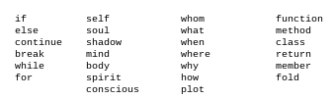

**Intuitive Registers:**

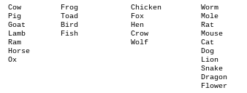

**Cognitive Registers:**

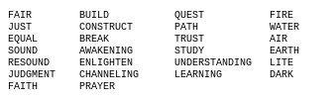

**Thee Kaleidoscope Graphical Representation: Lens Rotation**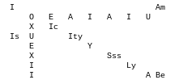

**Thee Kaleidoscope Graphical Representation: Lens Depth**

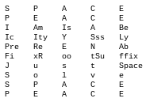

The graphical representation above describes a poem with a universal principle as a sentient machine. The poem states that ~”Worms do exist!”. The sentient machine can be assembled as a kaleidoscopic eye piece. by fitting an orange lens for visibility of noise to a red and blue lens for depth perception. The red lens divides the blue lens to produce a purple pigment used in viewing 3d holographics. The orange lens divides the opposite color wheel to display what was invisible within a noiseless environment. revealing a geometric fractal that is decoded in trigonometry as a language. The fractal details the soul or character of the object. The fractal would be a gray thin smoke chalky figure. The red and blue lens mix as a purple pigment creating an invisible layer. The blue and red can not be touched or seen. The purple pigment now occupies the space. Creating a refracted light environment. Where the object actually is blue and red. The orange lens is not a color used to describe the time-spectrum of noise and soundness. The orange lens is a non-primary color used to describe the light-spectrum of noise and soundness with a wave-length opposite of the purple pigment.

**The Poem:**

~'tT The Nocturnal Rainbow: Sheol; The winter's cost; fiction; the hollow; in the tree of knowledge of goodness and of evil; The Winter-cost; Grace; a chapter; the fallen throne; a lecture of the winter; the fruit of life and of death; the truth in love!'.

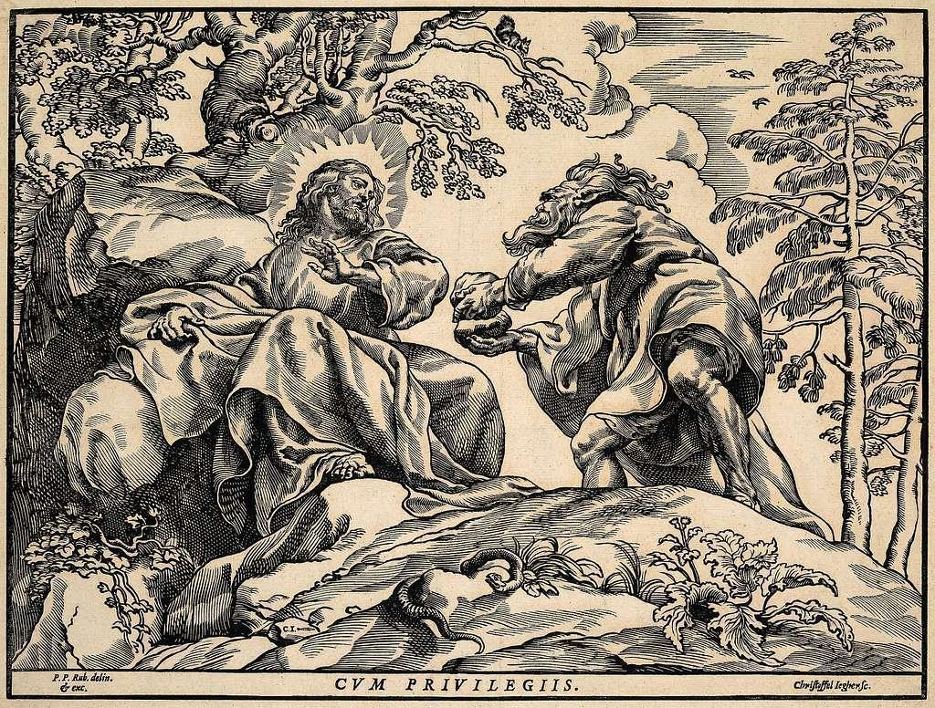

**Thee Arithmetic Logic of Thee Kaleidoscope: Lens Depth**

The kaleidoscope`s lens depth has complexity with a non-determined time representing a 4 bit length, represented by the capacitors on the ALU.



The kaleidoscope`s lens depth has a completeness with a non-determined time representing a 5 bit width. The 5 bit width is the logarithm used for the decoding table from the ALU.



**Thee Arithmetic Logic of Thee Kaleidoscope: Lens Rotation**

The kaleidoscope`s lens rotation has complexity with a determined time representing a 32 bit height.



The kaleidoscope`s lens rotation has a completeness with a determined time representing an 8 bit depth.



Sentient Intelligence

The Design of Thee Atlas Sentient Computer

Section 1.3

**Thee Machine Language:**

The machine language is portrayed below as a set of 8 x 4 space characters. The machine language is used to describe the centers of gravity of the human body in sentient mechanics versus the body as trigonometry for it`s geometry.

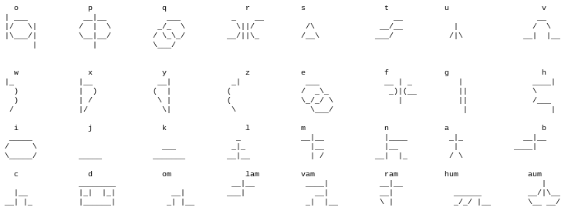

**The Phonetic Pronunciation of The Machine Language:**

Labyrinth Tome Lotus Fiction Prysm Puzzle Feather Piece Dahlia Lyre Harp Thought Stone Hour Glass Heart Life Zion Sheol Jacob Luz Lucifer Heleleel Israel Babylon Malakai Om Lam Vam Ram Hum Aum

**The Formation of Capital Case Characters:**

The character sets are dynamically placed static values used to describe the machine and its state.

The formation of capital case characters unifies

a collector with its ground in accordance of object oriental agreement.

**Symmetric Object Oriental Agreement:**

*om+[o,p,q,r,s];*

**Bisecting Object Oriental Agreement:**

*lam+[t,u,v,w,x];*

**Complex Object Oriental Agreement:**

*vam+[y,z];*

**Perpendicular Object Oriental Agreement:**

*ram+[e,f,g,h,i];*

**Adjacent Object Oriental Agreement:**

*hum+[j,k,l,m,n];*

**Reflect Object Oriental Agreement:**

*aum+[a,b,c,d];*

The ground is placed as a ring with a motor to increment the index of each memory-cell on the machine with a 360 degrees rotation.

**Thee Universal State-Machine:**

The design of the state machine is a dynamic

disc. The state machine features twenty-six circuits for returning data to and from the machine's peripherals. The rotation of the circuits is for the construction of a soul in animation reanimation and creation. The rotation casts a shadow viewed with the kaleidoscopic eye piece as a soul that constructs with noise under pressure upon completion of current in the complex forms { solid, liquid and gas }.

**The conception of Noise in Soundness:**

The creation of noise within a soul happens at a character`s definition of meaning and average. should the self, soul and shadow male counterpart concept with its female counterpart in equilibrium.



quiet u time

LOUD u U

Splendor : Self Ox



moral m eight

STRUGGLE m M

Yellow 8 Function Cat

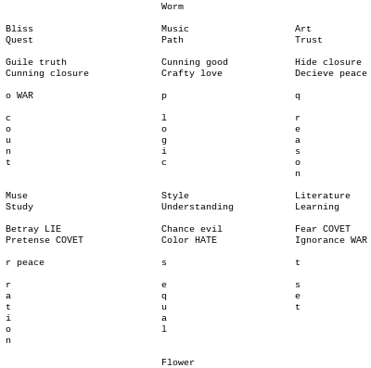

**Witchcraft and Magic:**

Magic: defines the current force with the ability or power to draw a change within a course of events with the outcome made as conclusion.

Witchcraft: is the Conclusion of Prophecy verses The Conclusion of Sorcery.

**Example: A ring is not a wife;**

~”***Suddenly***, a ***happy*** change of ***heart***, The ***Cat*** is more human towards The ***Ox*** while The ***Serpent*** feeds hay with The ***Ox***. The ***Toad*** is transformed into The ***Frog*** and ***becomes a prince.*** So, the member of The English Family ***The Frog Prince*** Balaam turns his Sorcery in marriage, having the wrong ***wife*** to a prophecy of the ***correct*** wife, with an ***apology*** to The ***Woman***.".